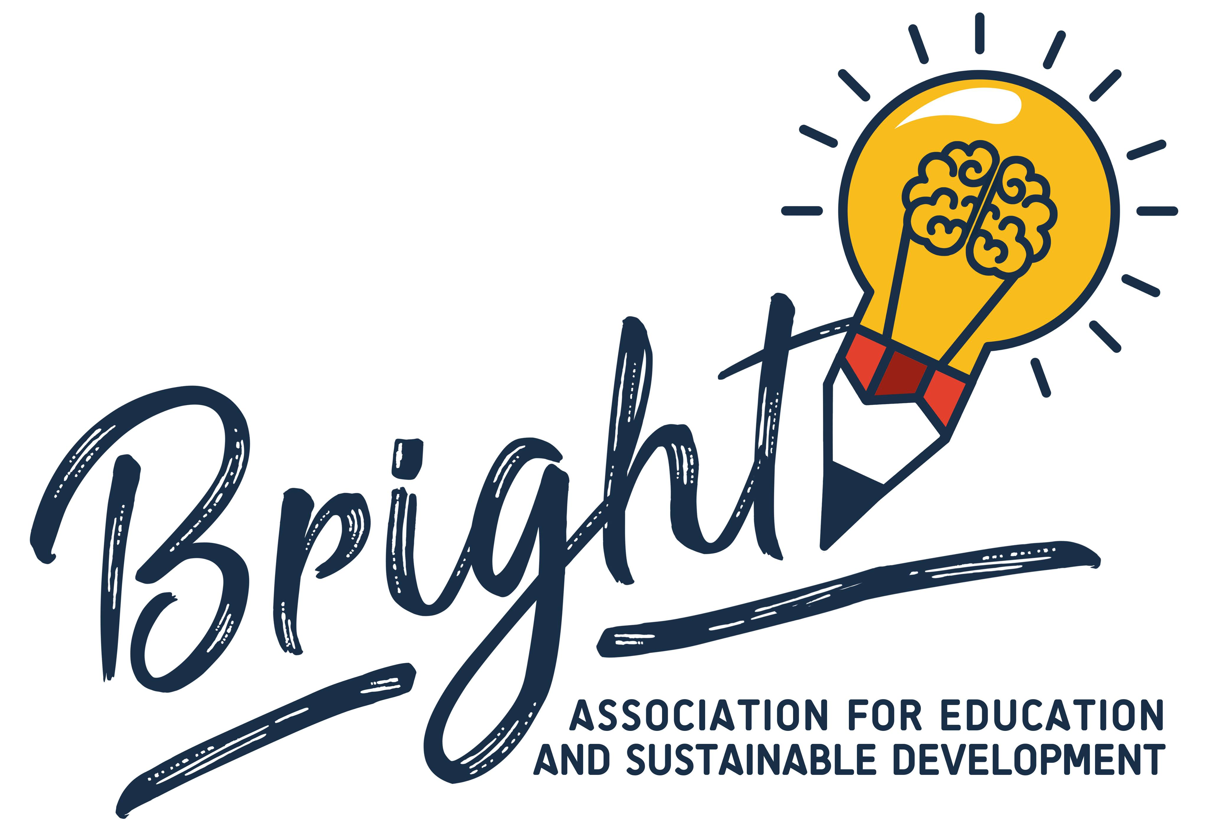
PIF

Applicant Details
OID Number | E10232078 (PIC: 896628425)
Full legal name (National Language) | Асоцијација за Образование и Одржлив Развој БРАЈТ
Full legal name (Latin characters) | Association for Education and Sustainable Development BRIGHT
Acronym | BRIGHT
Address | Orce Nikolov nr 155/4 Karpos- Skopje
Country | North Macedonia
Region | Skopje
Post Code | 1020
City | Skopje
Website | www.ngobright.com
Email | info.bright.mk@gmail.com
Telephone 1 | +38970321246

Background & Experience
Type of Organization | Association
Is the partner organization a public body? | No
Is the partner organization a non-profit? | Yes
Please briefly present your organization | Bright is a voluntary, non-profit, non-governmental civic association formed in Skopje in 2019.  The Association is carrying out activities for the promotion of moral values, strengthening of inter-ethnic relations and economic development of the state and beyond.  Bright strives to foster sustainable and developed local communities and improve the quality of life of citizens.  Our mission: Continuous improvement of the quality of life of citizens through sustainable economic, social and environmental development.  Our main objectives are:  - Creating more sustainable local communities and better quality of life for society.  - Organizing and coordinating activities related to achieving sustainable development, protecting and nourishing the environment, and tackling climate change.  - Promoting non-formal education and mutual cooperation among all stakeholders (citizens, institutions, business communities and international foundations, institutions and associations) in order to improve education, motivation and foster development.  - Implementing various educational activities for citizens, with special focus on youth.  - Caring for the promotion, development and improvement of the living conditions of all residents, with a particular focus on those with fewer opportunities (social focus).  - Undertaking activities to develop and improve the inclusiveness of vulnerable citizens in order to achieve sustainable economic growth.  - Contributing to the development and promotion of institutions towards increased effectiveness, inclusiveness, transparency and accountability.  - Encouraging initiatives to develop cooperation between institutions and citizens with the aim of exercising their rights guaranteed by the constitution, laws and international conventions.  - Collaborating with various educational institutions, organizations and companies in order to improve the standard of living and quality of life of citizens.  - Initiating regulations and strategies for sustainable use of the capacities of local communities and municipalities.  - Establishing contacts and cooperation with citizens, associations and networks of organizations both within the country and abroad, in order to stimulate the development of citizens, with a special focus on marginalized and underdeveloped environments, improvement of living conditions, and realization of human rights.  - Launching initiatives, projects and activities to improve (self) employment and (social) entrepreneurship skills of citizens, with a particular focus on youth.  - Investing in lifelong learning of the society in order to improve their living standard and quality of life.
What are the activities and experience of the organization in the areas relevant for this application? | Although Bright is a quite new young organisation formed in 2019, the staff members have relevant experiences participating, coordinating and facilitating different international projects. They are all committed to promote young people's active participation in social issues becoming an active European citizen. Every member has relevant experiences in the field of youth work. Bright's members have been actively involved in different projects' administration and implementation, especially in the field of (eco) employment, (social) entrepreneurship, environment and nature.  Many of our members have been active in activities with young people connected to development of the rural areas such as making youth and climate changes strategies of mainly rural municipalities, implementing trainings for volunteering for eco employment, implementing workshops for agro entrepreneurship and community engagement in less developed areas.  Some of the Activities that Bright is implementing related to its mission and goals are:  - Planning and implementing joint local, national and international projects;  - Organizing specific programmes and activities;  - Organizing events, conferences, seminars, trainings, trainings, exchanges and other activities;  - Encouraging initiatives by the competent authorities and institutions to achieve the goals of the Association;  - Works on research, analysis, manuals, guides, and other publications;  - Offering professional help, mentoring and coaching;  - Works in the field with the target groups using innovative learning methods.  In order to map and engage the young people in need we established strong network of national and international partners.  On national level we are cooperating with  - "MIT University, Skopje"  - High school "Saint Lucas", Skopje  - Small institutional orphanage houses  - Many local and national CSOs  With many of their young people and students we implement educational activities such as workshops and training's. for employability, soft skills and communication.  Also we build the capacities of their staff by sending them to international training's and study visits and we deliver training's for capacity building, pedagogical approaches and applying of ICT tools.  On international level we are cooperating with many youth organizations, networks, social enterprises and youth institutions especially focused on providing opportunities for young people and improving their current situation.
What are the skills and expertise of key staff/persons involved in this application? | The organization consists of a big team of highly educated, motivated and dedicated people.  We have a great mix of staff with various backgrounds, competences and interests, ranging from University professors to youth workers and young people.  Petko Gjorgjevski is the President of Bright. He has over 30 years of managerial experience as a sales manager and director and over 20 years he has been a general director of “Teteks Knitting” one of the main knitting companies in North Macedonia. For 2 years he was president of the men’s football club Teteks which played in the second league and moved to the first league. He has been a managing member in several (youth) organisations where he was leading and took part in many different projects and activities.  Hristina Vidojevska is a member of Bright. She is a MA student at the Faculty of Economics in Skopje and a former member of AISEC. She is in the governing board of accreditation of Universities in North Macedonia, thus being in charge of deciding which faculties will be granted with permission to work. Among other projects and training, she took part in the Start-up academy of SWTA Skopje, the training on Marketing and Emotional Branding of European University in Skopje, she participated in the Budget Transparency project of USAID, and the Budget Monitoring training of CEA. Her interest has recently slightly shifted from economics towards educating young people and youth workers, which has resulted in her active participation in local trainings and activities.  Toni Dimovski is a member of Bright. He had been awarded with a BA degree in auto mechanics at the Faculty of Machinery in Skopje. He has been involved in several organizations as a volunteer, striving to improve his soft skills and engaged to help improving the community. He is an active and engaged citizen, motivated to contribute to the development of his region.  Lazar Gjorgjevski has been awarded with a BA degree in Business and Economics and a Master Degree in Marketing. He has been part of several organisations, managing many youth projects. He has vast experience in project management, logistics and finances especially of international projects.  Zarko Ilijevski is a former camera man and editor of the regional radio and TV “KISS”. At Bright he is in charge of the (social) media appearances and activities, dissemination of the project results.

Legal Representative
Title | Mr
First Name | Petko
Family Name | Gjorgjevski
Position | President
Email | info.bright.mk@gmail.com
Telephone 1 | +38970321246

Contact Person
Title | Mr
Gender | Male
First Name | Zarko
Family Name | Ilijevski
Email | partners.bright@gmail.com
Telephone 1 | +38970321246
Yes
Has the partner organisation participated in a European Union granted project in the 3 years preceding this application?

